ExaO: Software Defined Data Distribution for Exascale Sciences

Introduction
The Large Hardon Collier produces large-scale datasets for the CMS experiment every day. Such datasets are distributed, stored and analyzed in a global, multi-domain network, where each participating institution contributes computing, storage and networking resources. Yearly over 50 petabytes of raw data are generated at the Tier 0 site in CMS experiment, and multiple fold of derived datasets are generated and analyzed at different Tier 1-3 sites across the world. Current dataset transfer systems in CMS, such as PhEDEx, were developed over a decade ago. The total volume of active datasets managed by PhEDEx is approximately 200 petabytes. And on an average day, 400 to 500 datasets transfer requests are received. Each dataset contains hundreds to thousands of files with a median size of 3 gigabytes. PhEDEx is built on top of traditional multi-domain networks, and schedule users’ dataset transfer requests with a static, dataset-level scheduler. The inflexibility of infrastructure and the scheduling policy lead to low transfer concurrency and resource utilization in the CMS network. With the data volume in CMS approaching one exabyte, a more flexible, efficient data distribution service is required to provide better data transfer experience for participating scientists.

Designing a flexible, efficient data distribution service, however, is a non-trivial task as we need to address a series of challenges. First, such a distribution service must have a real-time, global network view from the multi-domain CMS network. Secondly, a dynamic scheduler needs to be developed to fully leverage the potential of destination hosts as file providers and hence achieves high data transfer concurrency. Thirdly, intelligent orchestration between different traffic flows is needed to maximize the utilization of network resources, e.g., bandwidth. None of these issues was considered by current data transfer services in CMS, e.g., PhEDEx and ASO. To cope with these challenges, we design ExaO, a software defined data distribution for exascale sciences.

Figure 1. Comparison of features between PhEDEx and ExaO.

The ExaO data distribution address the above issues by introducing several innovative components. First, we implement the Application-Layer Traffic Optimization protocol (ALTO), in particular, the simple path computation engine (ALTO-SPCE) and the routing state abstraction (ALTO-RSA) services. In each site, an ALTO server is deployed. The ALTO-SPCE agent at each site computes real-time, on-demand intra-domain routing information, and the ALTO-RSA agent uses this information to compute on-demand, minimal, equivalent abstract routing state.

Secondly, we design a logically centralized, dynamic, file-level scheduler that fully leverages the potentials of destination hosts as file providers to achieves a high transfer concurrency. The scheduler also allocates network resource, e.g., bandwidth, among different traffic flows in the network to maximize the network utilization. The scheduling and network resource allocation decisions are enforced at different end hosts through a simple yet efficient rate-limiting agent.

Figure 2 provides an overview of the ExaO service. End users can submit, track and manage dataset transfer requests via RESTful APIs. In addition, current data transfer services in CMS, e.g., PhEDEx and ASO, can also redirect requests to ExaO using these APIS. All transfer requests are stored in a database. The ExaO scheduler queries the database periodically to get newly submitted requests, and queries the ALTO controllers deployed at each site, who collects complete network state in each site and computes on-demand, minimal, abstract routing state in response to the query. With information of dataset transfers and network state, the ExaO scheduler makes centralized, dynamic, file-level scheduling and global network resource allocation decisions and records these decisions in the database. Meanwhile, Transfer Execution Nodes (TEN) query updated scheduling and allocation decisions from the database, and instruct efficient data transfer tools at different end hosts (e.g., FDT) to enforce scheduling and allocation decisions. During the transmission, the MonALISA sensors at each site monitor data transfer status and send update back so that the scheduler can adjust bandwidth allocation decisions.

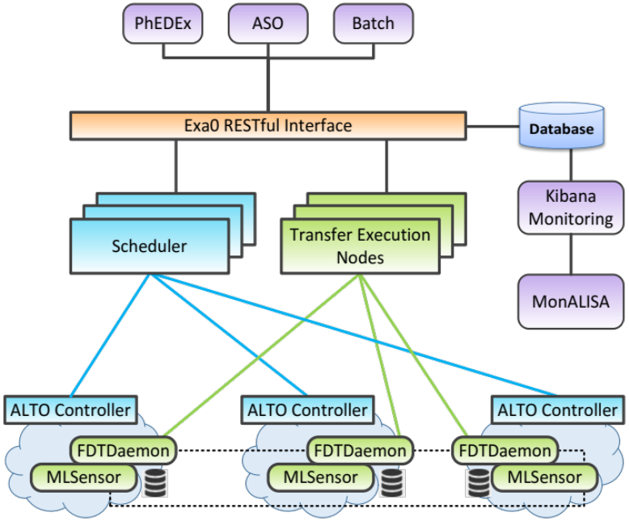
Figure 2. An overview of the ExaO data distribution service.

Demonstration
In SC16, we demonstrate the powerfulness and efficiency of ExaO in a typical one-to-many dataset distribution scenario. In an 2-switch, 8-host network with multiple 40Gb and 100Gb links, two datasets, each of which is originally stored at only one source host, are required to be distributed to two different groups of hosts. In the current PhEDEx data transfer service, data transfers only happen between the original source hosts and the corresponding destination hosts. resulting in poor bandwidth utilization. In the ExaO service, on the contrary, the transfer scheduler fully explores the potential of destination hosts being file providers, and schedules each destination to forward the received files to other destination hosts. In this way, not only does ExaO achieve multiple times higher bandwidth utilization than PhEDEx does, it also reaches the theoretical upper bound of bandwidth utilization.

Future work
Focusing on achieving high network resource utilization, ExaO is our first step to leverage the innovative SDN technique for resource orchestration in the CMS program. In the CMS computing model, not only network resource, but also computing and storage resources are scarce and demanded by various large-scale, complex scientific data analysis jobs. The feasibility and benefits of an efficient, scalable and robust multi-domain multi-resource co-scheduling system remains unexplored, and is the investigation target of our next step. ExaO and the future multi-resource co-scheduling system will be evaluated on various SDN testbeds, including the NCL testbed at National University of Singapore, the GTS testbted at the GEANT association in Europe, and the 100Gb SDN testbed in Caltech. We plan to deliver the produce version of both systems in the next 12-18 months.

